

**INNOVATION & INCUBATION**

**CENTER OF EXCELLENCE**

**1. Entrance of COE**

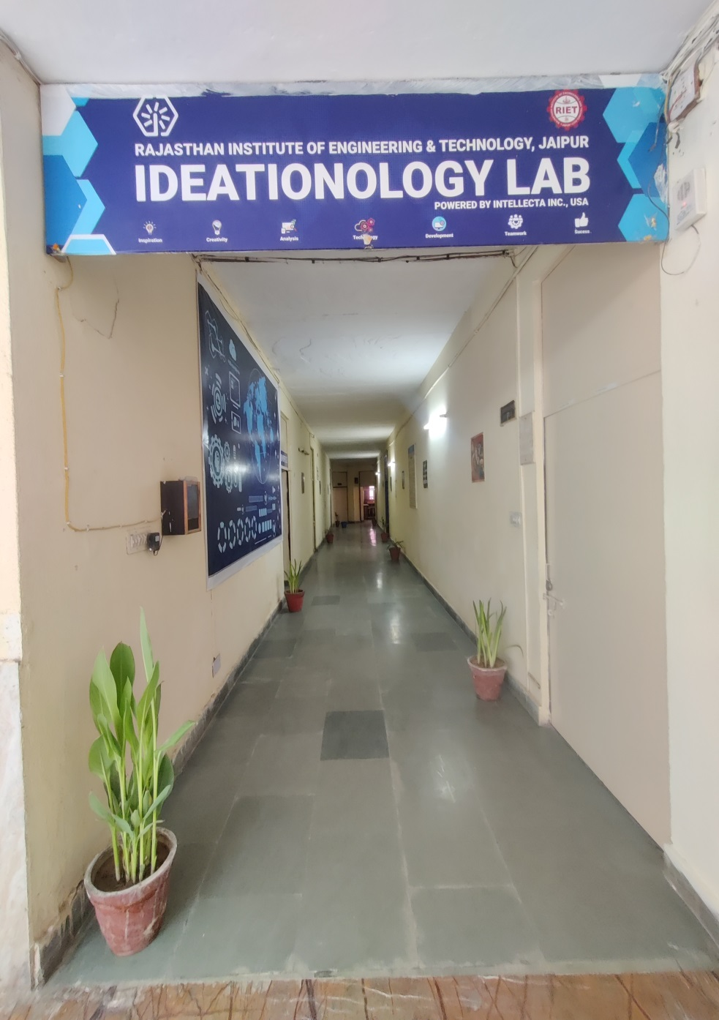 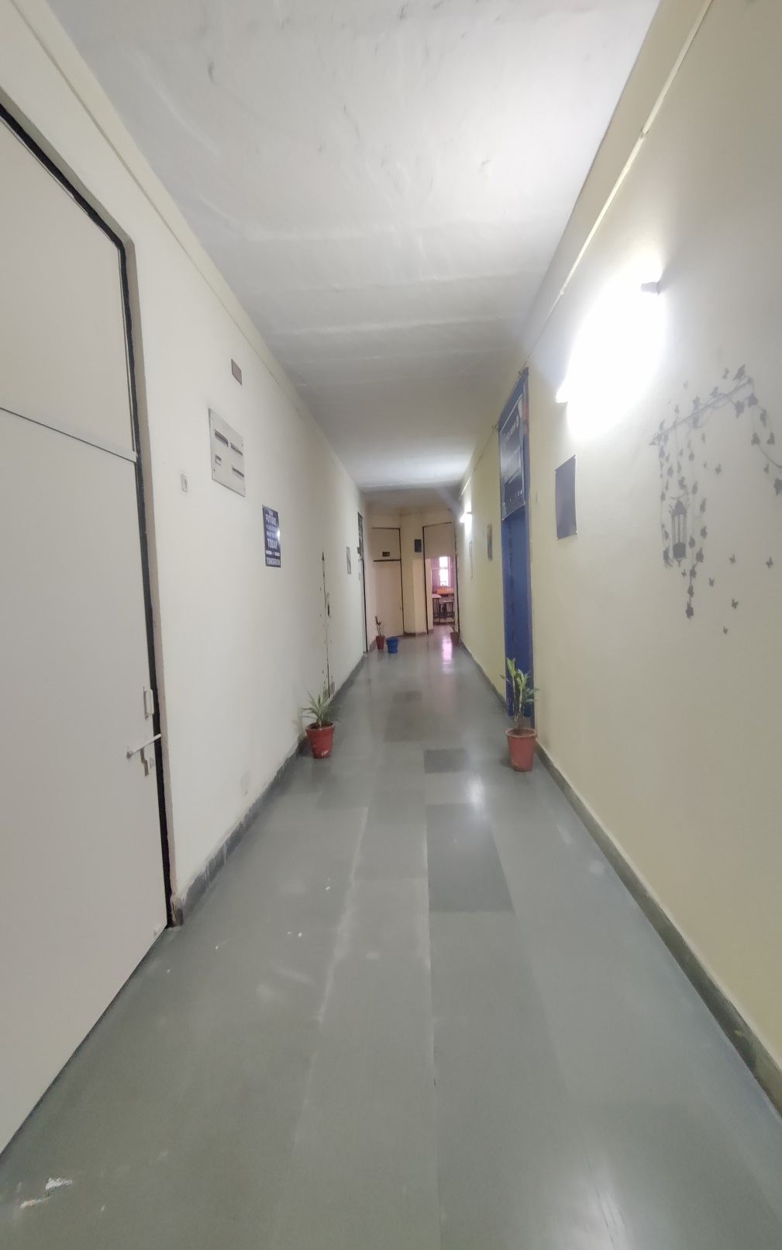

**2. Training /Seminar/ workshop lab**

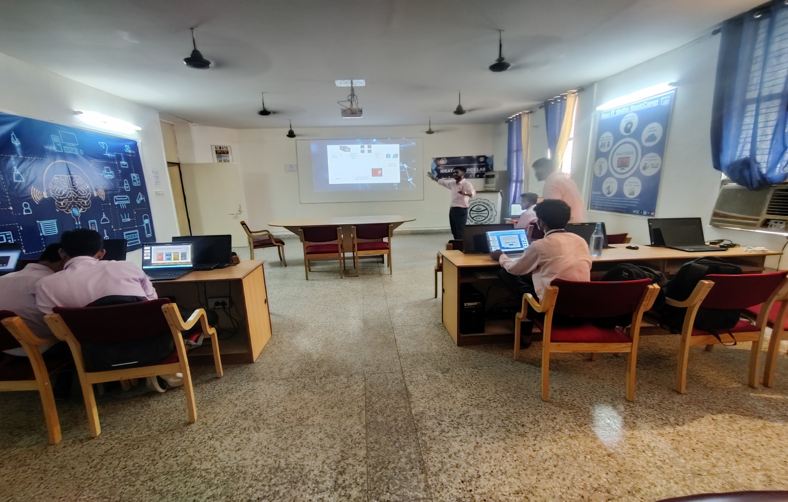

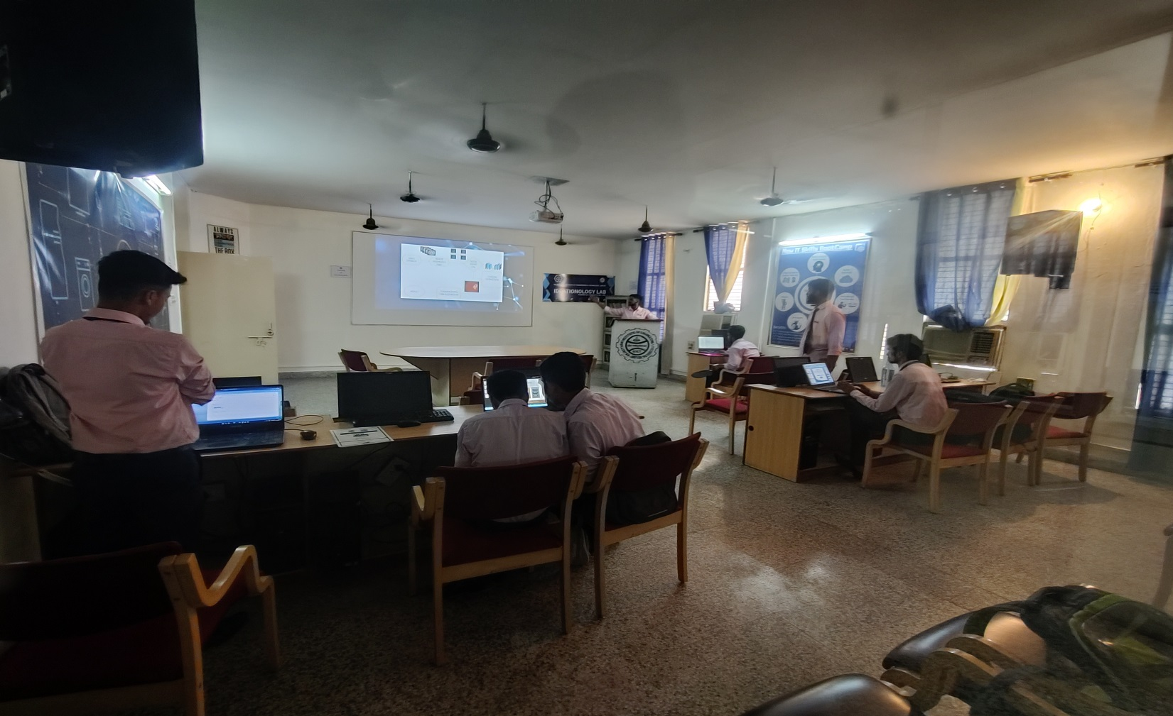

**3. Idea Innovation lab:-**

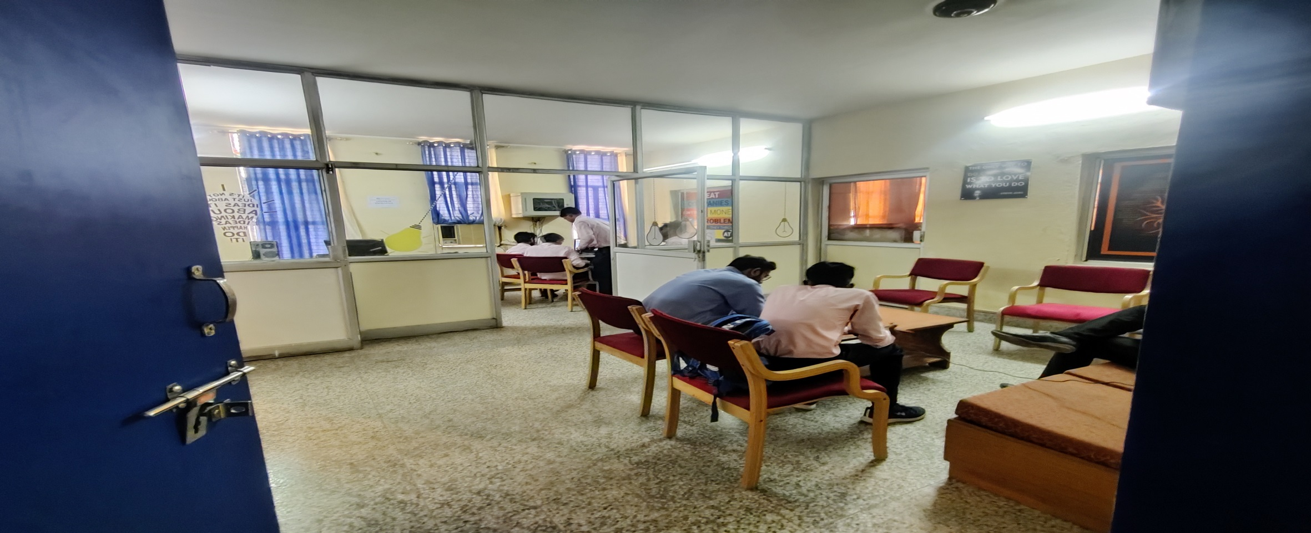

**4. Faculty /Mentor Seating and Discussion Area:-**

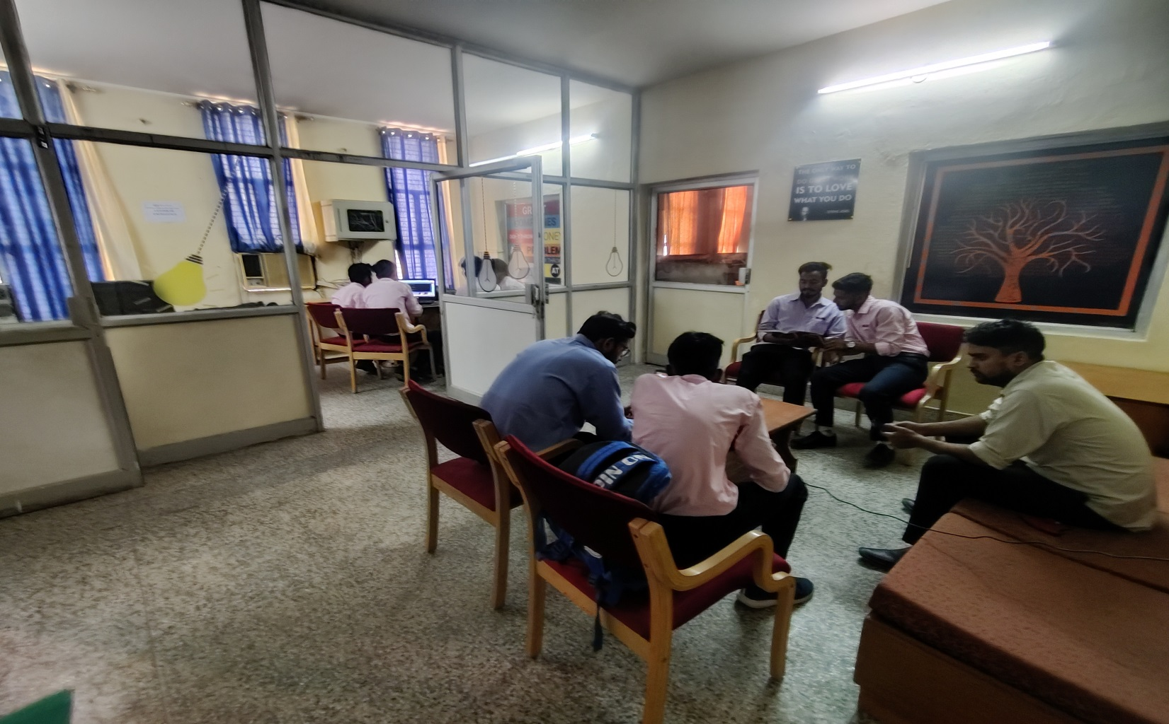

**5. Robotics and Innovation Center Lab:-**

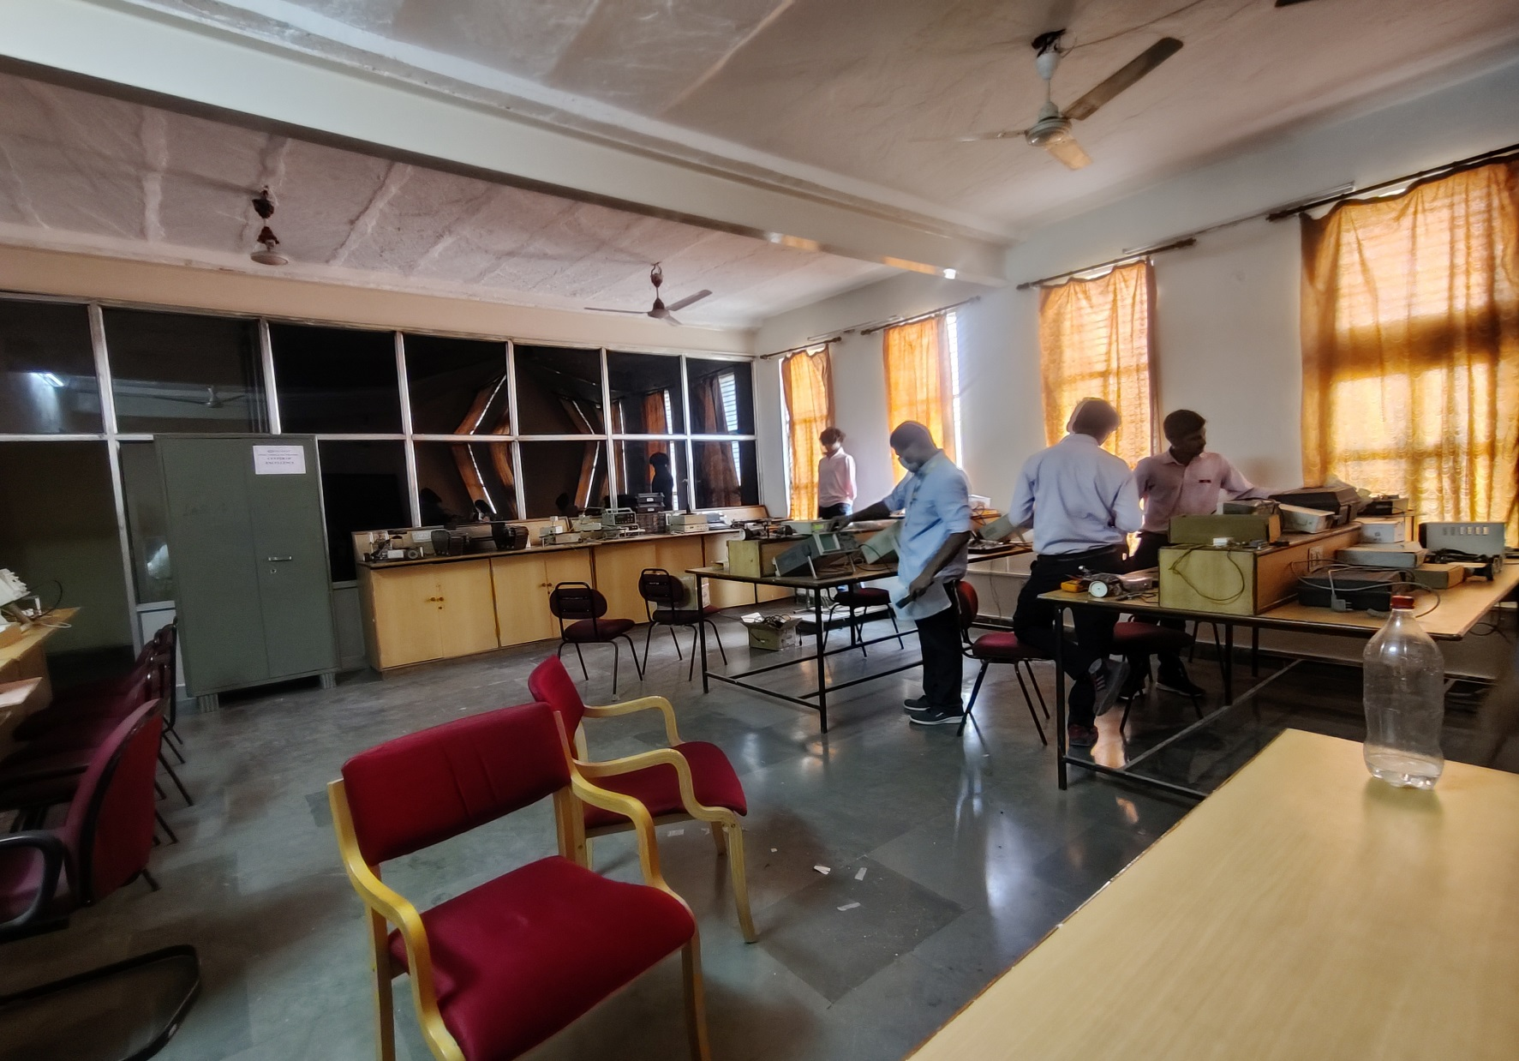

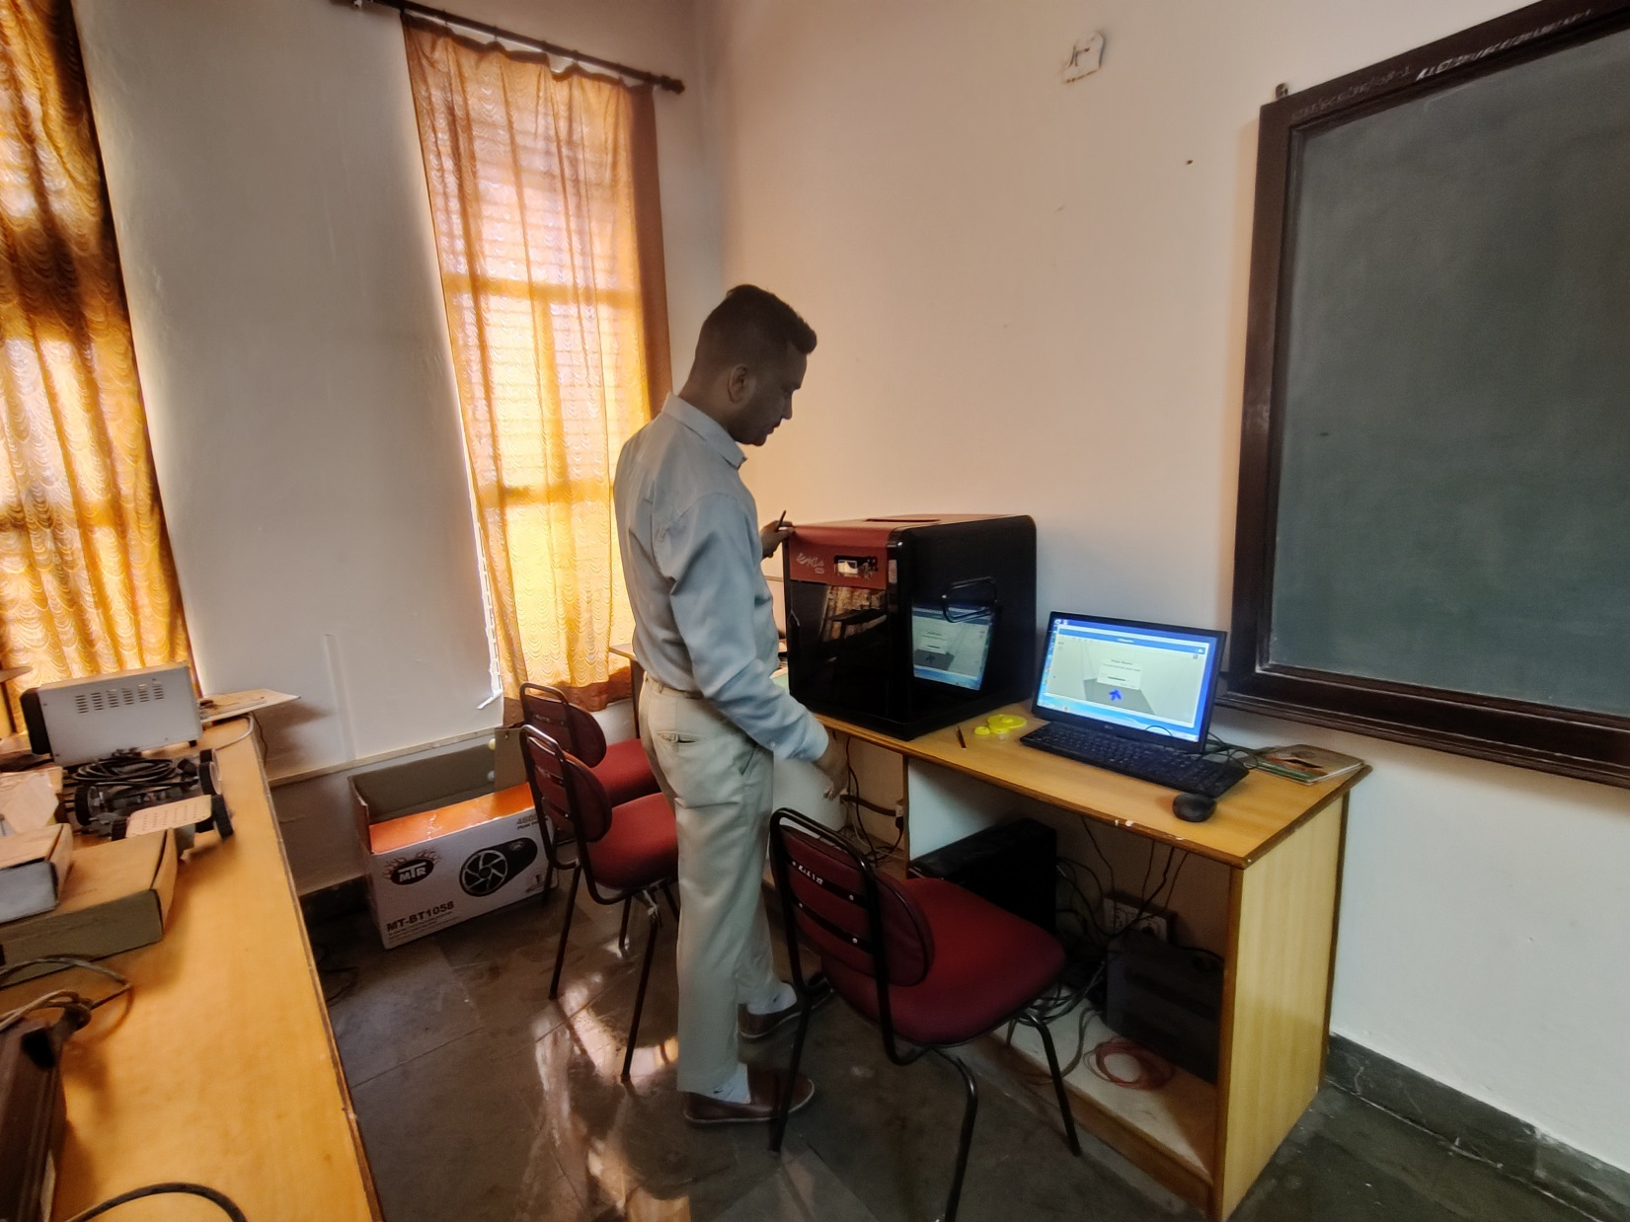

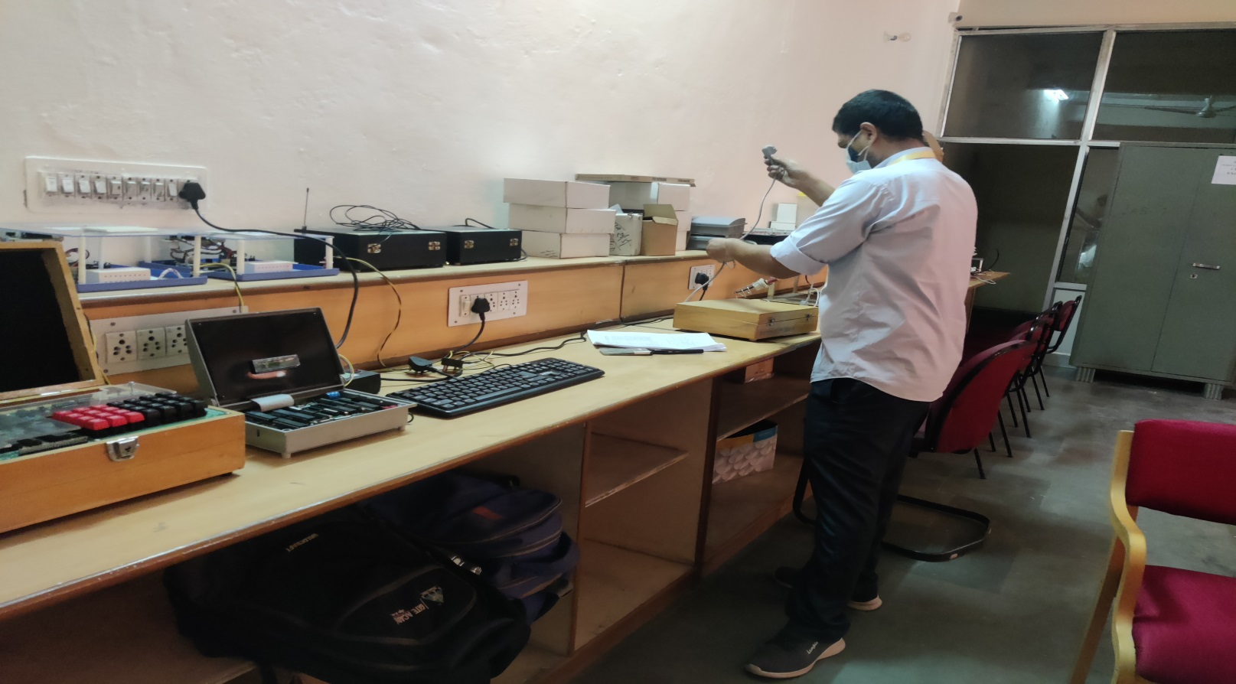

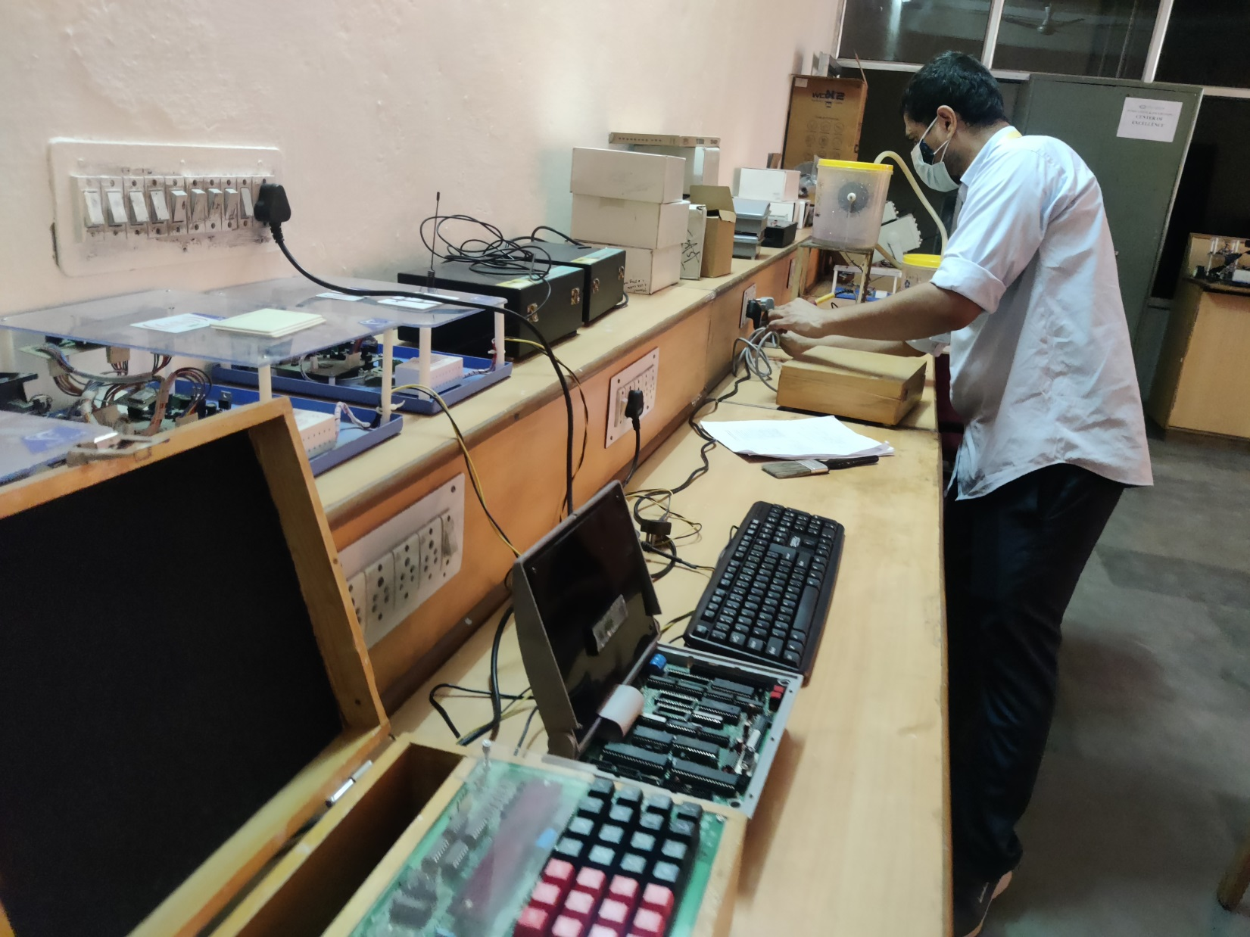

**6. Projects and Ideas**

**1) Robotics Car:-**

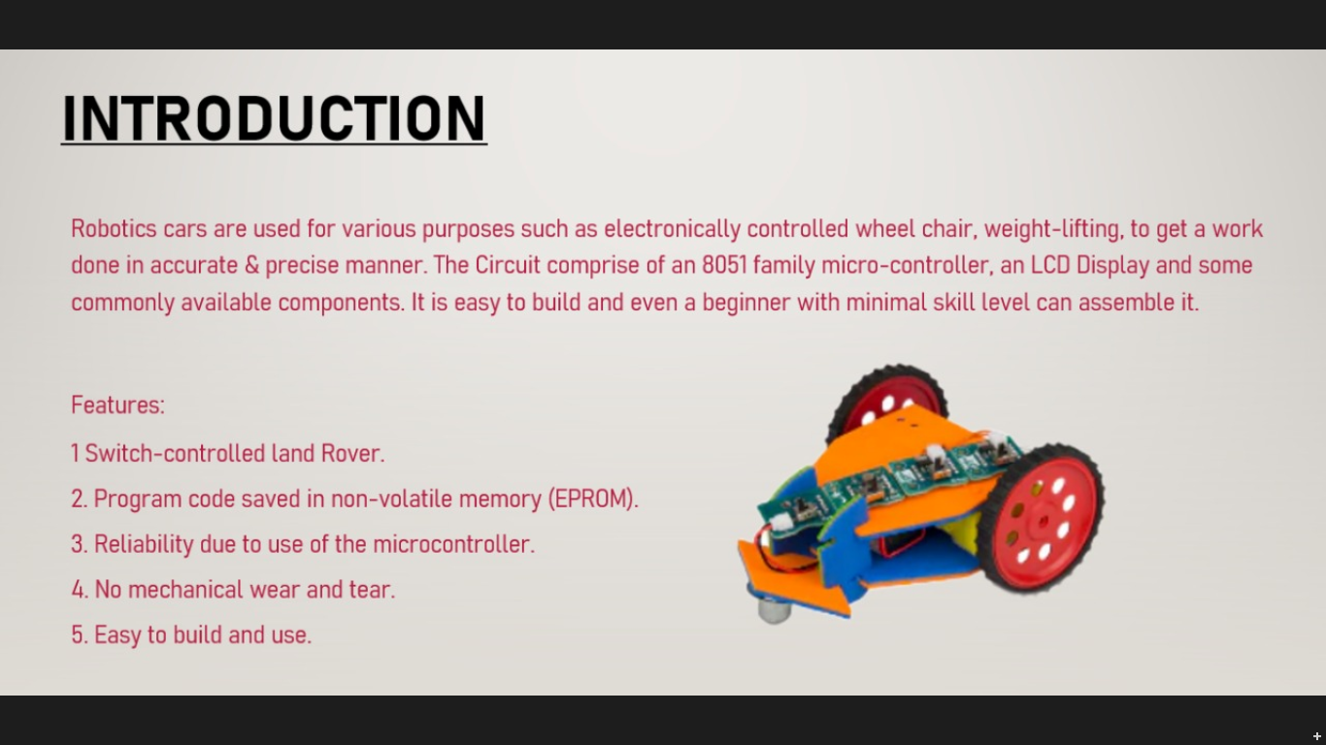

**2) 3-D Printing :-**

Objective of the execution of this project focused on the small skill development & involvement and making a base knowledge of 3-D printing outputs by which further enhancement of real world project execution can be understood easily and output shall be efficiently taken.

* Printing 3-D formation of Old Castle Brick in true dimension.
* Using available 3-D printer small scale production of the sample can be studied.
* Further feasibility of the available recourse can be enhance as per requirement.
* Making available the study and research environment to all for further enhancement of the project.

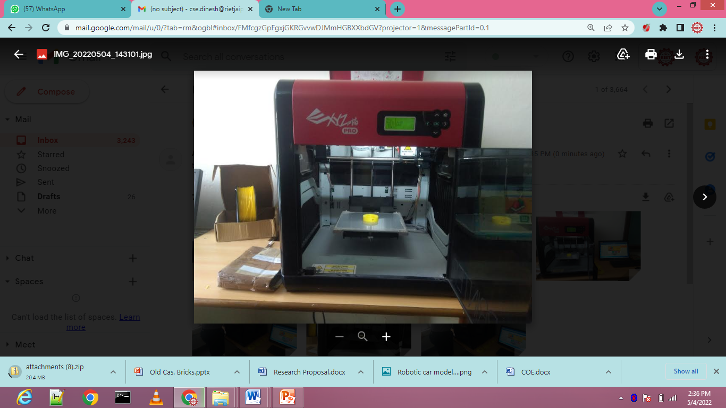 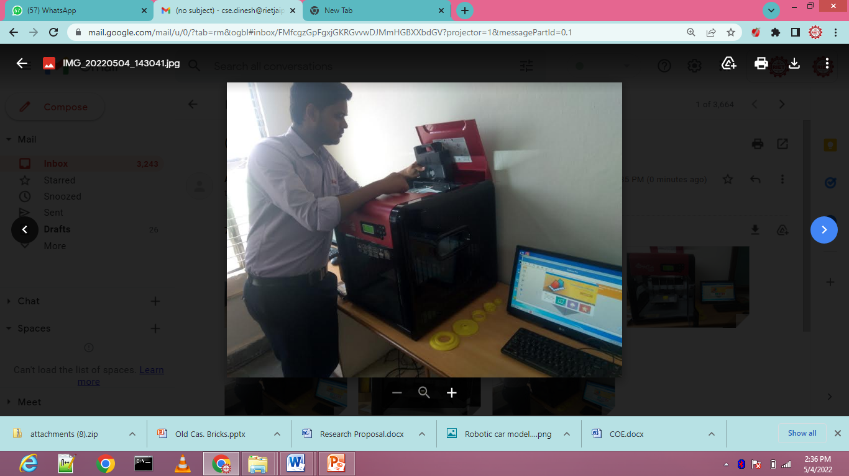

**3. Home Automation Website**

Using our Home Automation Website, we can control the Home Appliances from anywhere Worldwide until ESP32 are connected to the internet.

Live Project :-

https://imvicks.herokuapp.com/#vickscroll

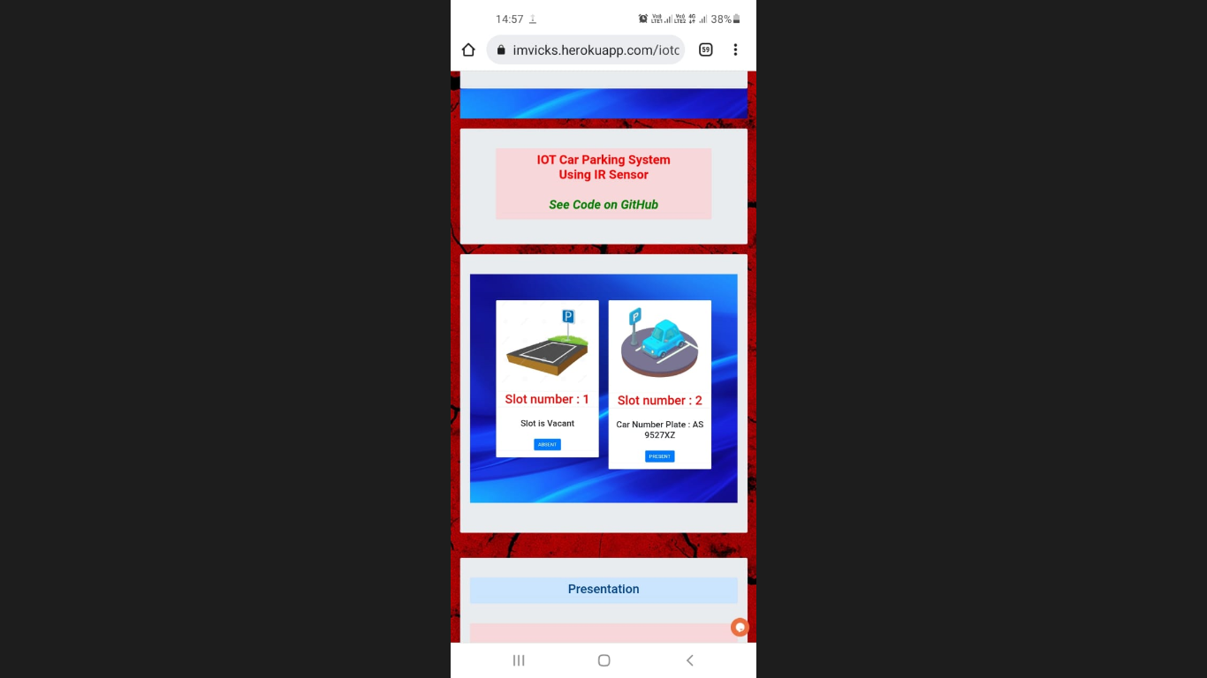 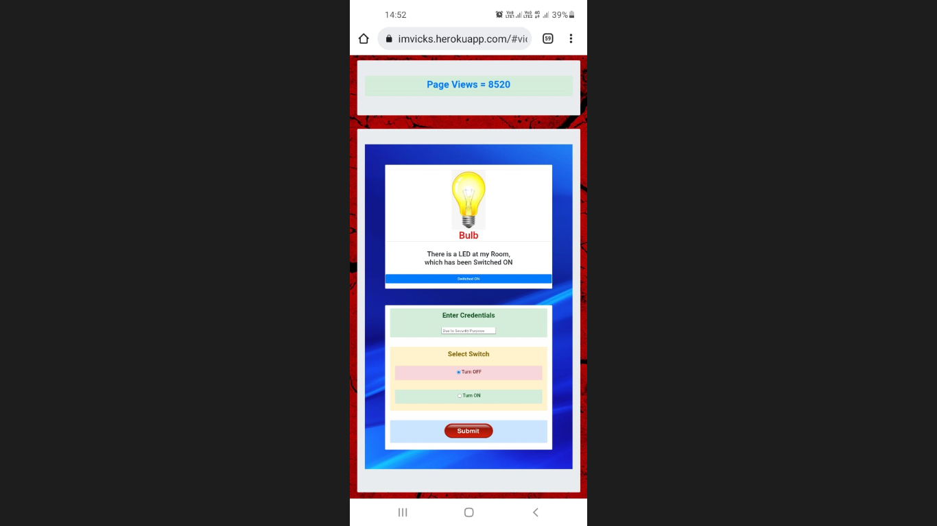

**4.Car Parking Management Website**

In today's world, the era of growing population, more spaces are required to park our vehicle. In growing cities this is the big issue to find the suitable parking area.

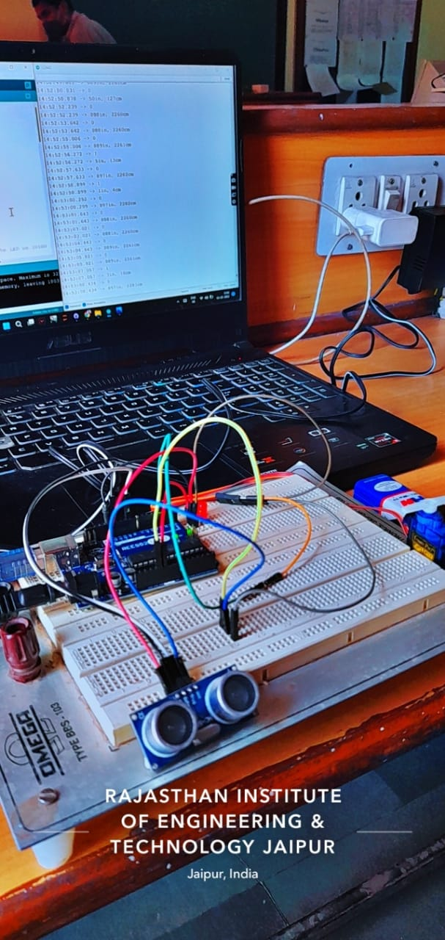 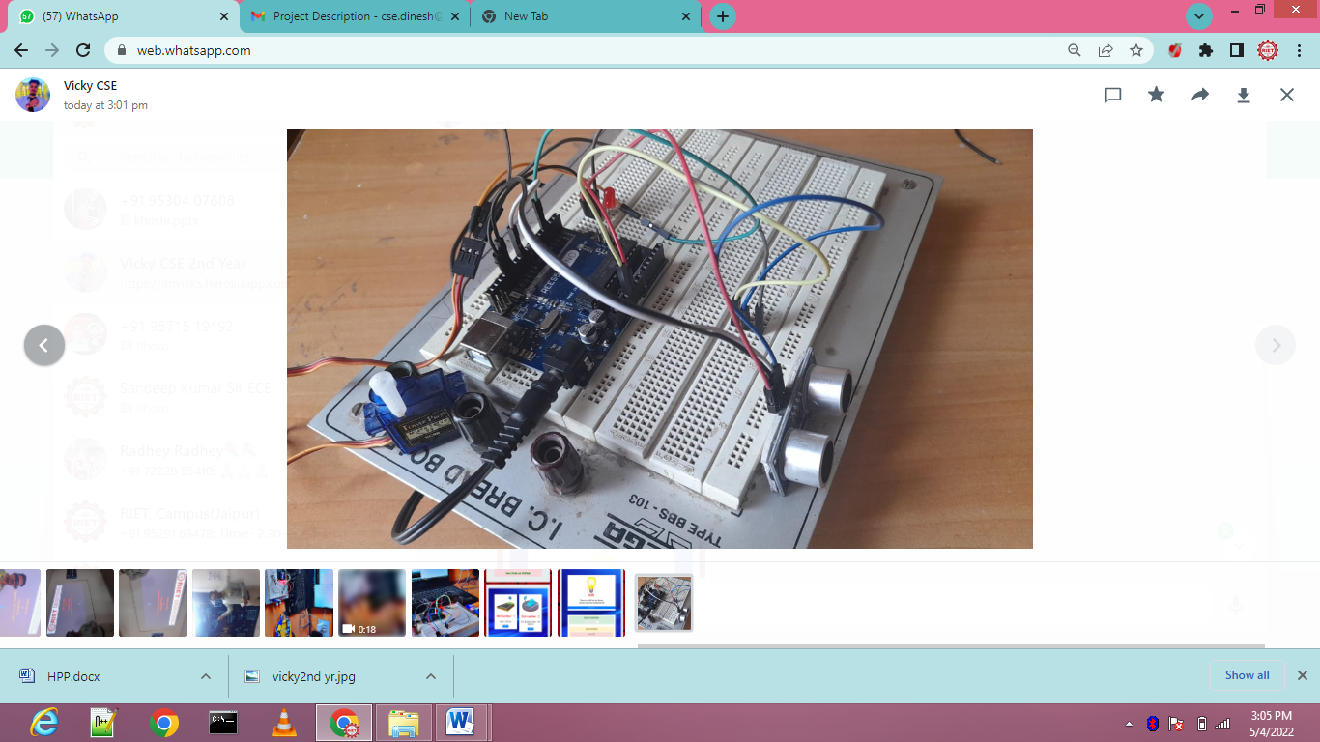

**5.Hydro power plant (Prototype model):-**

The most common type of hydroelectric power plant is an impoundment facility. An impoundment facility, typically a large hydropower system, uses a dam to store river water in a reservoir. Water released from the reservoir flows through a turbine, spinning it, which in turn activates a generator to produce electricity.

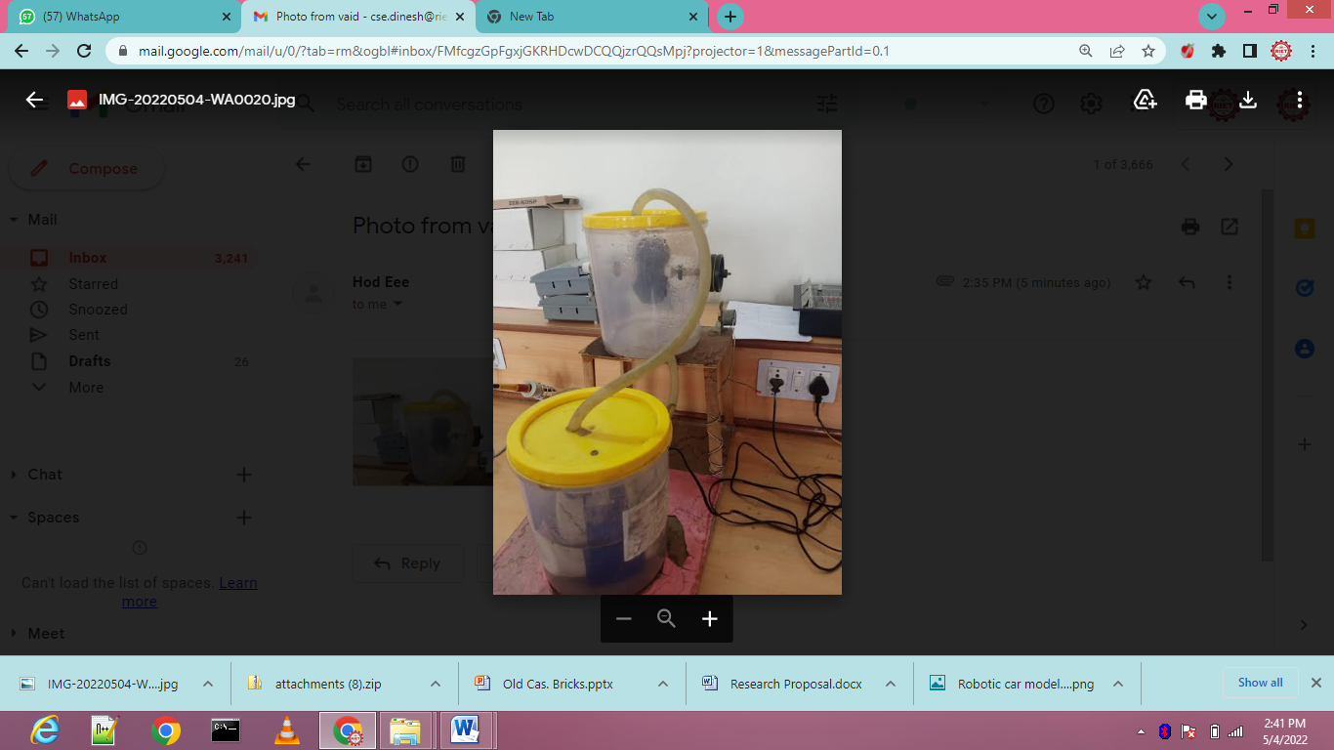

**6.**  **Smart Glasses**

**To aid blind people with ultrasonic obstacle detection.**

**Hardware:**

**- Arduino Uno**

**- Ultrasonic sensor**

**- buzzer, wires etc.**

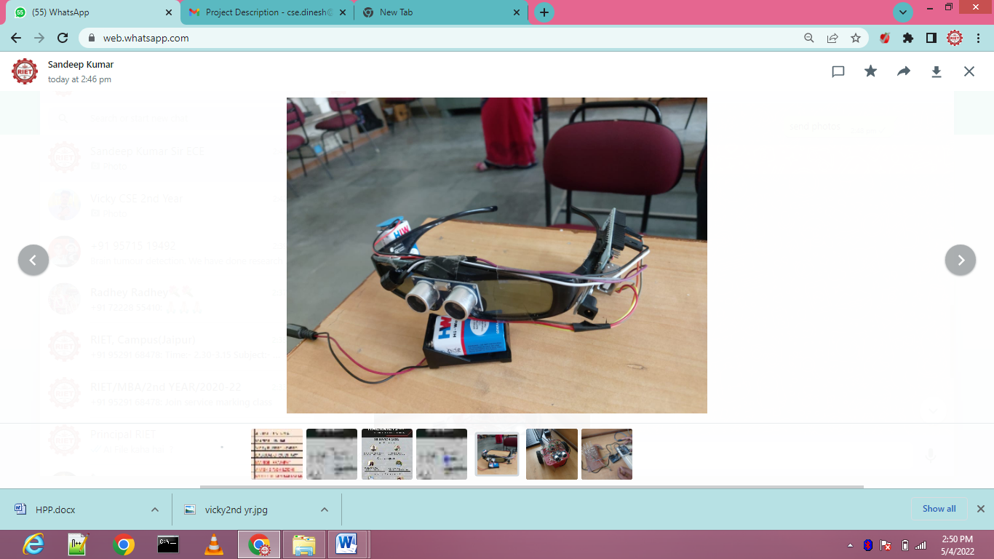

**7.Intelligent Robot**

**Hazard/Landmine detection system**

**Hardware:**

**- Arduino Nano**

**- Servo motor**

**- DC motors etc.**



**..............................**

**8) Lighting kit**

**3d led cube with multi lighting programing. 4x4x4**

**Hardware**

**- Arduino Uno**

**- LED, wires etc.**

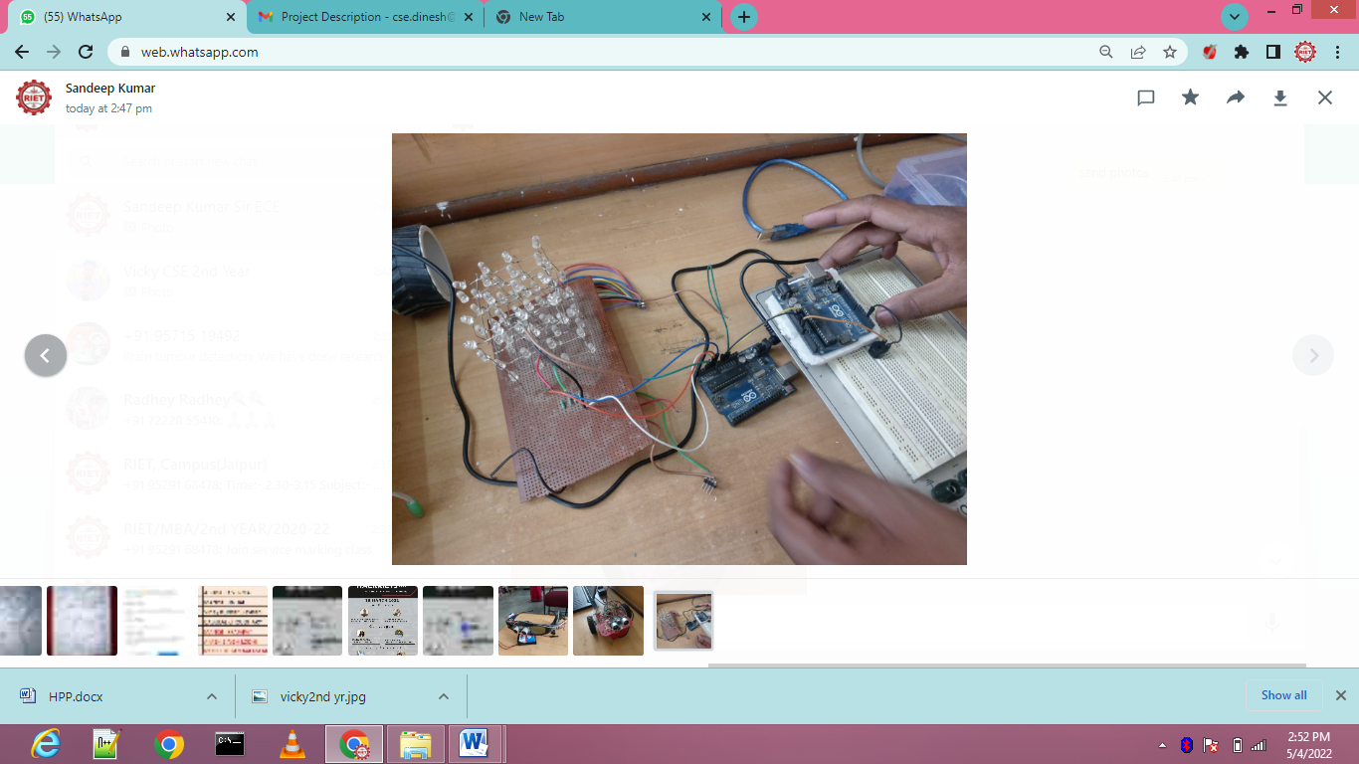

**.................................**

**9) Lowcost Music Generator**

**Produces pre- programmed music.**

**Hardware:**

**- Arduino Uno**

**- buzzer**

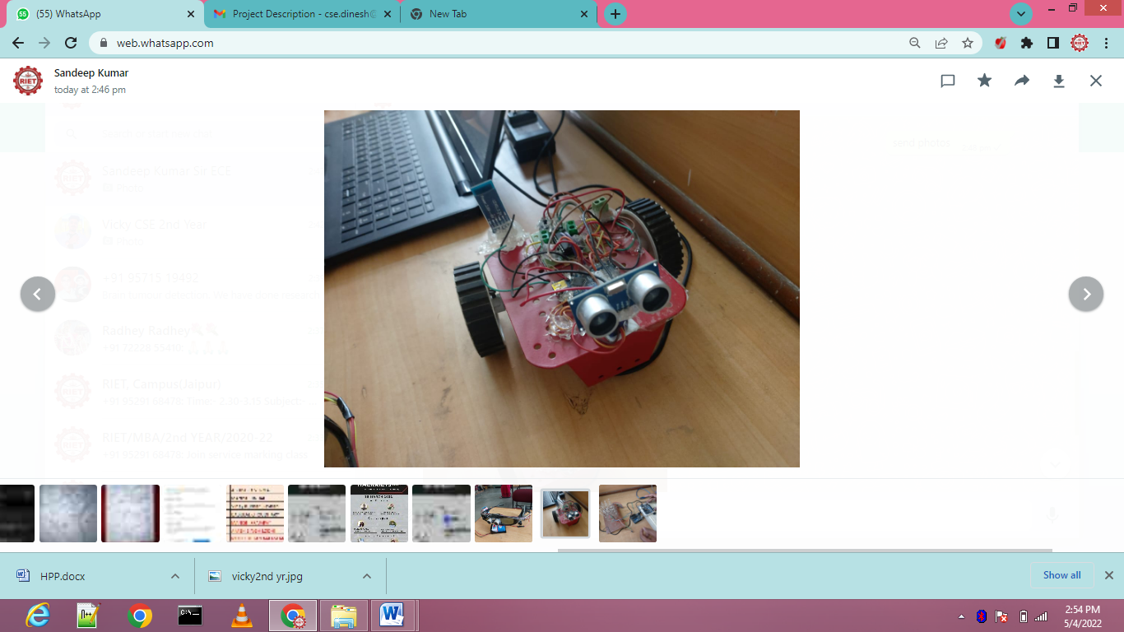

**9.) Brain Tumor detection:-**

We have done research on this topic and found that in 2018, 28000 cases were detected in India of brain tumor. Out of which 24,000 died. So it may be due to lack of facilities. Or may be due to lack of doctors. So we have decided to create this project. In this project we have done the Brain tumor detection of scan MRI Images using CNN. The methodology we have used in this project are Image Acquisition , Image Pre-Processing, Image Segmentation, Feature Extraction, Classification, Convolutional Neural Network . We are getting an accuracy of 89%. And this is a running model.

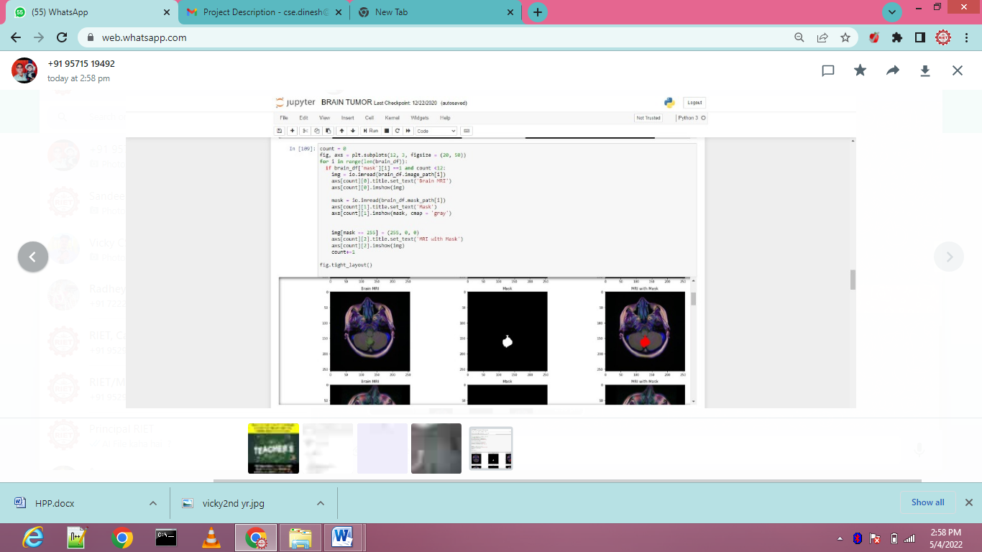

10. **SUSTAINABLE ENERGY THROUGH ROLLING SPEED BREAKERS**

Speed breaker is used for the break the speed of vehicle but in this project we use this in another way. In this traditional speed breaker is replaced by the roller mechanism.The concept of the rotating speed breaker is nothing but the one small step to reduce the use of conventional source of energy. In this we use roller which is connected to the gears through bearing using shaft. The bearing is used for increase speed and shaft connected to roller used for balance. The couple gears are used. One gear is connected to the shaft and another small gear is connected to the shaft of generator. Electricity is produced as speed breaker is rotate through gear.

* **This project is helpful in hilly as well as in remote area where light is not reached.**
* **The electricity produced from this technique is used for street lightning, for signals, and for the lightning for the check post**
* **This technique of electricity production is practically applicable at the place of high density traffic region.**

